Lake and River Ecology Project Proposal:
Zooplankton and Phytoplankton Repopulation and Algae Cleanup

- Cover Sheet (See Attached)
- Starting Testing:
Although there is significant amounts of research that support the viability of this procedure, if requested we could perform small scale testing in order to prove the effectiveness of the Daphnia at eating cyanobacteria.
  - Briefing
In order to perform the first phase of this operation, we would require four 500 gallon tanks in order to grow Daphnia specimens and eight 200 gallon refugia in order to grow algae samples. We also would require a small area (2,000 square feet) and any upkeep costs related to said facility for six months. We would then dump small amounts of Daphnia into the water and measure the overall changes, if any, that are caused by the Daphnia introduction over the period of one week over multiple tests and on multiple different strains of cyanobacteria (two per tank, Anabaena, Microcystis, Anabaena and Microcystis, and Control)
Although there are possible benefits to performing this stage, there are multiple studies that have tested this on a similar scale and found promising results such as P. Urrutia-Cordero, M. K. Ekvall & L Hannson's study in 2016.
  - Cost Analysis
The overall cost for the small scale testing would be quite low.

4 x 500gal Tank ($2,000)
8 x 200gal Refugium ($3,000)
1 x UV Sterilizer ($10,000)
1 x RO/DI Purification System ($15,000)
Rent (~$30,000 (Minimum of 1 year))
Worker pay (~$7,000 / month)
Bills (~$1,500 / month)
Chemicals and Supplies (~$1,000 / month + $2,500)
Insurance (~$400 / month)
Total: $62,500 + $9,900 / month ($119,400 total for 6 months)

Flat Costs | Monthly Costs
$32,500 Materials and Supplies | $1,500 Bills
$30,000 Rent | $7,000 Workers
$ 10,000 Shipping | $1,000 Chemicals and Supplies
 | $400 Insurance
$72,500 Total | $9,900 Total / Month

  - Identification & Significance of the Opportunity
The primary objective of this proposal is to use biomanipulation techniques in order to mitigate or entirely remove the risks posed by cyanobacterial blooms in bodies of water effected by eutrophication and/or return zooplankton and cladocerans that natively populate these bodies back to normal distributions, we would increase the amount of natural predators of the cyanobacteria, safely lowering them down to more acceptable levels. There are several studies (see citations) that prove the veracity of this technique, which has previously been tried on small scales in other countries which were effected by similar problems. We will be evaluating four major data points:
  - Starting and Ending cyanobacteria ppm
  - Total Cyanobacterial Surface Coverage
  - Starting and Ending Zooplankton and Cladoceran population
  - Cyanotoxin Concentrations

The second stage of the proposal (which is not included in this document) would involve refilling the now available niche created by the absence of cyanobacteria with benign species of native phytoplankton through mass breeding and dumping. After this is completed, routine checks will have to be performed to ensure that a proper ecological balance is maintained between native zooplankton and phytoplankton until a more permanent solution is found.

The finalized plan would be a two stage process:
- Breed and re-establish native Daphnia populations in order to restore them back to healthy levels (approximately raising them by 150% of their current levels, which matches EPA studies from 2005) for watersheds that aren't affected by acidification. Although this may cause the removal of some non-toxic and benign algae species, in the event of a cyanobacterial bloom most of these species are already in a near non-existent state (>= 1% of algal biomass). This will remove the barriers created by cyanobacteria that prevent native plants and algae from utilizing the nutrients that they normally would be able to access.
1a. In addition to the Daphnia re supplementation, physical breaking up and removal of mats formed by cyanobacteria would expedite the process by allowing Daphnia to more easily digest the material.
- Replenish the body with beneficial, or at the very least, benign native species of phytoplankton in order to fill the ecological niche that cyanobacteria were holding, in order to prevent them from returning as rapidly.
- Repeat when necessary in order to maintain healthy levels, balancing Daphnia and phytoplankton injections in order to maintain an equilibrium and the overall health of the lake.

2.1 Background
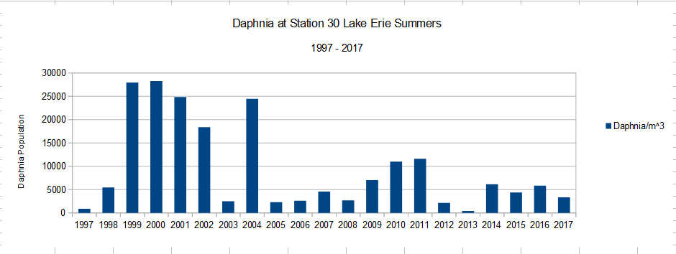
As the human population continues to grow, farming is a necessity. However, runoff from this farming process is inevitable and often leads to negative effects, including the topic of this paper, cyanobacterial blooms. A cyanobacterial bloom happens when excess nutrients from farming runoff and other industrial activities cause a large spike in native cyanobacterial populations, causing them to choke out other forms of native life and generate toxins. However, it is likely possible to greatly mitigate these effects using the common water flea, which is capable of eating away at these bacteria.
Cyanobacteria have a large variety of detrimental effects on their local environment, both biologically and economically. Because of the fibrous nature of cyanobacterial colonies, they will often deprive large areas of lakes and other standing bodies of water of oxygen, leading fish and other aquatic life to suffocate. Furthermore, many types of cyanobacteria produce toxins that are harmful to most large life forms, including humans and dogs. The combination of these two effects can lead to the closure of many beautiful areas that either rely on infested bodies for drinking water, or tourism.
According to Epp, as far back as the late 1990's the cyanobacteriophagal properties of the genus Daphnia were known to be effective, with “the phytoplankton reduction achieved seem[ing] to be an exponential function of the ratio of phytoplankton volume to Daphnia biomass.” (Epp, 1996, pg. 565). The data gathered by Epp shows that as the ratio of Daphnia logarithmically increases, the drop in the population of cyanobacteria over the course of the experiment will increase linearly. Due to this factor, it would likely be beneficial to introduce the maximum amount of Daphnia possible, as quickly as possible, in order to expedite the removal of toxic organisms. In addition, rapid removal of the cyanobacteria is likely the most effective method, as cyanobacteria react to the presence of macro-zooplankton predators by changing their layout in a way as to render them more difficult to consume.
In addition to its native ability to process cyanobacterial toxins, Daphnia shows remarkable durability in the presence of new conditions, allowing versatility in the field. Over two years, Daphnia samples were able to shift thermal tolerance by four degrees Celsius due to natural and man-made climate shifts (Geerts et al., 2015) and can withstand a significant range of PH values, with the optimum range being from 6.5 to 9.5 (Weber, & Pirow, 2009), allowing for distribution to multiple climates in order to combat cyanobacterial blooms around the country. The most important type of adaptation that Daphnia is capable of is the ability to adapt to feeding on different types of toxic cyanobacteria, with a period of only 3 to 6 months required to fully acclimate them to the new toxin, although they can continue to graze from day one at the expense of their fecundity (Jiang, Gao, Zhang, Liang, & Zhu, 2016)
However, average Daphnia populations around North America have suffered a decline of between 50% and 85% according to EPA data collection ("GLENDA (Great Lakes Environmental Database Query System)", 2017) from 1997 to 2017 (See Figure 1 in Graphs section). This would prevent them from performing natural grazing that would suppress cyanobacterial blooms. The largest issue is the trend of water acidification; Because Daphnia are are an arthropod species, they have outer shells composed of calcium, which is extremely susceptible to low PH conditions. Due to the expansion of human industry, many lakes are now at PH levels that significantly suppress Daphnia reproduction, meaning that outside intervention will be necessary.
The problem of low Daphnia reproduction is further exacerbated in bodies that are affected by high cyanobacteria populations; although the toxins produced do not necessarily kill the Daphnia, they do increase the stress required for them to sustain themselves, and as a result have a significant negative impact on reproductive rates (Maggie et al., 2004).
There are quite a few benefits to supplementing local Daphnia populations, as they are a cornerstone of many ecosystem's food chains, and an increase in population would likely lead to a flourishing of local wildlife, from fish to many other animals that live near treated lakes and ponds.
In addition to Daphnia, which may not be viable in certain areas, there is also the species of zooplankton Diaptomus Dorsalis (And the entire Diaptomus) that has been found to graze on cyanobacterial blooms in eutrophic areas. In addition, subspecies of Arctodiaptomus have been found to graze on cyanobacteria (Tolomeev, et al., 2010) in relatively high salinity environments, low temperature environments. In fact, Tolomeev et al. shows that all species of macro-zooplankton are capable of grazing on cyanobacteria, although diatoms may be preferred when they are available.
This point in particular is of particular interest, especially when combined with the extremely rapid adaptations of Daphnia subspecies. Over a short period of time, we will be attempting to specially breed and acclimate small populations of Daphnia, in particular Daphnia Pulex (both due to it's global presence and it's ease of acquiring should a sample die) to specific breeds of cyanobacteria that are posing problems around the US and Canada. This would allow for easy selection and allow a specifically targeted approach towards local populations, potentially rendering it significantly more effective over simply dumping in generic specimens or using other methods to clean a eutrophic lake.
One concern that is often brought up is the method by which Daphnia preferentially select food. Although Daphnia are known to heavily target non-fibrous phytoplankton (which are most likely not the cause of the bloom), in most lakes that are at the point where bioremediation would be needed, non-problematic phytoplankton typically make up between one and five percent of the total phytoplankton biomass. Because of this, the problem could be simply be brute-forced through the introduction of sufficient amounts of Daphnia. Supposing this is not possible, it is still likely that a slight but significant cyanobacterial reduction will be seen. According to Urrutia-Cordero, Ekvall, & Hansson, Daphnia still have a “potential to enhance the ecological and societal value of eutrophic water bodies.”
This selective targeting by Daphnia also brings into focus a second issue that is present in many lakes directly affected by cyanobacterial blooms – a significant decrease in beneficial and benign phytoplankton populations. There are many reasons that this can happen, from the natural ability of cyanobacterial colonies to moderate their buoyancy in order to maintain optimal conditions of sunlight exposure – giving them a significant advantage over stationary and current bound phytoplankton - to cases where cyanobacteria begin optimizing their habitat for their own needs on a large scale, such as cases where cyanobacterial colonies were found to be causing normally neutral lakes to reach pH levels of nearly 10.5 (López-Archilla, A.I., Moreira, D., López-García, P. et al., 2004). This ability is present among many phyla and genii of cyanobacteria, with nearly all of them preferring an alkaline solution, and when they are present in significant amounts they begin to produce chemicals that will rapidly adjust the pH of their medium towards this number. (Wildman RB, Benner BL, Held DD, Schauberger CW, 1974). Although cyanobacteria cannot survive in acidic conditions, with a pH of around 4 completely inhibiting their growth while still being suitable for many Arachea, and pH levels below 6 significantly hindering their ability to rapidly reproduce (which would likely prevent most blooms except in extreme circumstances where extremely large amounts of aqueous nutrients allow for cyanobacteria to overcome this barrier), the addition of phosphoric byproducts from chemical runoff adjusts the acidity of the bodies of water towards a neutral pH, which likely allows cyanobacteria to not only gain nutrients (phosphorous and the nitrogen and carbon that often comes with it) but also to gain a much more foothold in environments that they likely would not normally be able to. From there, chemical runoff allows the starting population to grow to levels that it normally would not be able to should the pH be lower.
Because of these effects, cyanobacteria will nearly inevitably rise to become the dominant photosynthetic organism in an affected eutrophic body of water, while also preventing native species from spreading or sustaining themselves, leading to the rapid drops in population that are seen in many affected lakes. Therefore, it would be beneficial to introduce algae that could stabilize the pH to a less extreme level in order to prevent, or at least hinder re-emergence of the cyanobacteria. This would be a second project that would likely take place once the Daphnia begin to stabilize the lakes, at which point the PH should naturally dip and slow their breeding, as they too prefer basic solutions due to the nature of their calcium shells.
Because of the ability of cyanobacteria to change the pH state of lakes that they infest, it seems that Daphnia populations would do relatively well – as they too prefer basic conditions due to their chemical composition. However, in bodies such as Lake Erie, Daphnia populations are extremely low, as shown in the graphs provided through the EPA monitoring data. Therefore, there must be something else causing the population decline, which will require further investigation.
In addition to dumping of Daphnia Magna and Pulex, we also would be able to dump other beneficial breeds of zooplankton and cladocerans in order to help bolster native populations. The most prevalent species that we would be able to do this with would be Daphnia Ambigua, Eubosmina Tubicen, Cernodaphnia Riguardi (Haven, 2002). We also could add other non-cladocerans such as Diaptomus Dorsalis, which are naturally present but currently in diminished numbers. Not only would this help increase the number of natural predators that would be grazing on the Zooplankton, it also would increase the available resources for local fish and wildlife.

- Main Objectives
The primary objective for our operation will be utilizing natural predators of cyanobacteria (Namely, Daphnia) in large amounts in order to curb populations, and open an ecological niche from which beneficial and benign native algae can be allowed to reproduce. This will be done through the creation of Daphnia Breeding facilities from which specimens will be injected into the affected body near high density clusters of cyanobacteria, allowing the Daphnia to consume them and restoring them to normal population levels.
This would be most effective on lakes that are severely affected, as it would increase the likelihood of the Daphnia grazing on cyanobacteria rather than their preferred phytoplankton.
- Take baseline measurements for the body of water on which we are experimenting.
- Set up facilities.
- Perform dumping procedures.
- Take weekly measurements to gather data on progress
- Compare the data points to determine how much improvement has been shown over time.

- Work Plan
4.1 Schedule

1) Find land that meets requirements
- Land MUST have direct access to water.
- Land has available power hookup or generator location that minimizes noise pollution in order to not cause complaints
- Preferably non-residential (due to industrial nature of project)
- ideally optimally location with current or flow to disperse daphnia

2) Land preparation
- Level pads for tent(s) and generators if needed
- Install temporary power poles, junction boxes if power is available
- Piping, water intake, temporary sewer hook up if available and city water hook ups (for work site bathrooms) or honey buckets and city water hook ups
- Setup of temporary fence for worksite
- Additional site preparation: gravel in high traffic spots, OSHA safety requirements (additional fencing, and safety)

3) Facility set up
- Plan site and facility layout
- Tent Setup
- Electric service / generator hook up
- Portable office and night manager building placement and wiring.
- HVAC systems
- Flooring placement
- Tank and system placement
- Plumb and wire facilities
- System setup (temperature controls, salinity controls, purifier setup)
- Security Implementation
- ALL OSHA work site requirements and extra requirements will be met if possible in order to get lowest insurance rate

4)Cultivation and Daily Release schedule.
  - Tanks will be on a 19 day cycle.
  - Tanks will be started simultaneously and be distributed to maintain optimal population growth
  - One tank will be released per day per facility that is active.

  - Reporting
We will be giving weekly reports of the data that we collected under the four categories mentioned above.

- Related Work
See references

- Future Research and Development
If this project is successful, there are several locations that could greatly benefit from the implementation of this or similar methods in order to reduce local cyanobacterial populations. This also could be used to repopulate existing lakes even if they do not have an issue with cyanobacteria, as Daphnia are very good for bolstering native fish populations in commercial hatcheries or local bodies of water.

- Commercial Development Strategy
This project can be pitched to any companies that produce large amounts of nitrogenous or phosphoric waste water, such as agricultural corporations, in order to minimize their impact on local bodies of water. This could also be used in order to rejuvenate bodies of water with low rotifier counts, which would increase biodiversity and local fish populations.

- Key Personnel
Ethan Szlovak – CEO, President
Christopher Lea – Vice President

Simeon Florea - Head of Research

- Facilities and Equipment

Figure 1: Life Support System
- x3 Treated Water Tanks
- x2 Generators
- Primary Life Support
- Plumbing
- Wiring
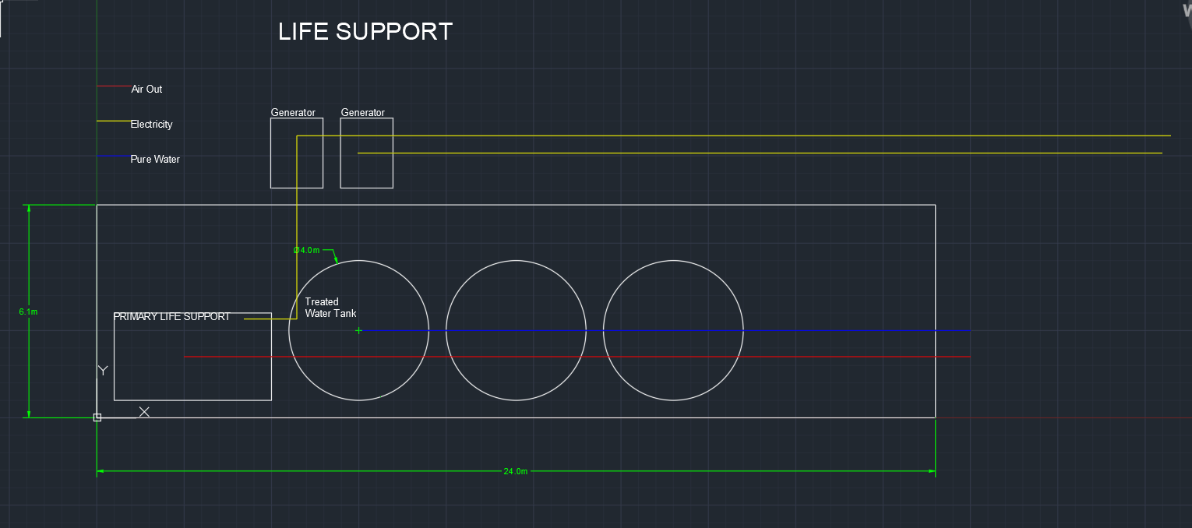

Figure 2: Growth Modules
- x10 Breeding Tanks
- x1 Water Storage
- HVAC
- Life Support Systems (Air Pump, Temperature Control Systems)
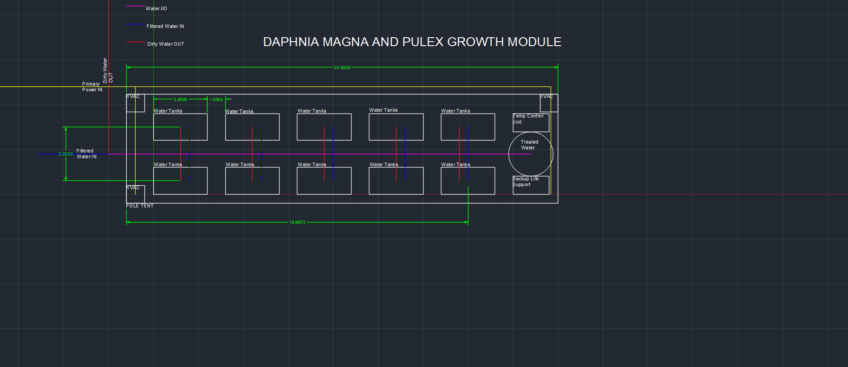

Figure 3 Water In Module
  - Pump System
  - Generator Systems
  - Plumbing
  - Wiring
  - Reverse Osmosis Systems
  - UV Sterilizers
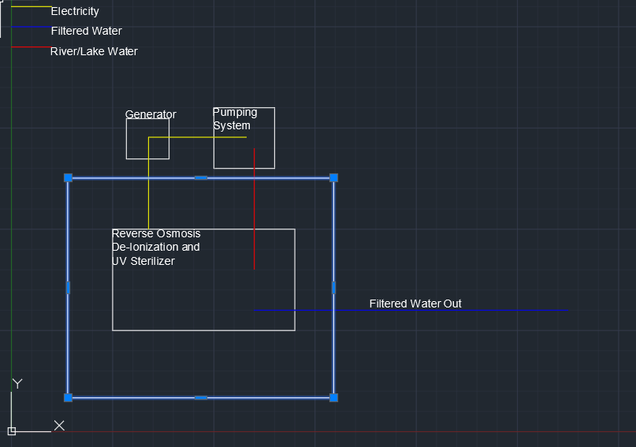

FIGURE 4 : Alternative Design (Single System)
- 17x Breeding Tanks
- 1x Cleaned Water Storage
- 1x Generator
- HVAC Systems
- Life Support Systems (Air Pump, Temperature Controls)
- Plumbing Systems
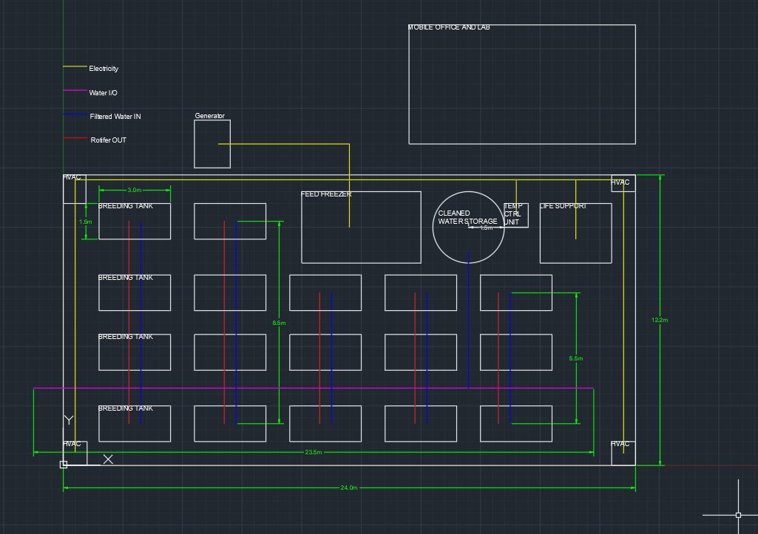

- Consultants
No consultants will be necessary in this operation

- Prior, Current, or Pending Support
None.

- Cost Proposal
Equipment Costs – $175,000
- Pole Tents (2 * $15,000)
- Generators ($20,000)
- Water Filtration Systems ($ 40,000)
- Tank Systems ($ 45,000)
- Water Storage ($ 15,000)
- Pump and Piping Systems ($ 15,000)
- HVAC Systems ($ 5,000)
- Air Pumps ($ 5,000)
Labor Costs – $31,500 / month + $5,000 For initial setup and safety requirements
  - 3 Daytime (1 Labor and 2 Management / Labor)
  - 1 On – Call
  - 2 Night (1 Manager, 1 Laborer)
  - 1 On Call
  - Per Diem Cost of $1500 for lodging and food.
This would be the cost to pay us and any laborers that we hire.
Supply Costs – $10,000 / Month
The total cost for fuel, materials, food, and any consumables.
Insurance Costs - $2,500 / Month
TOTAL:
Flat Costs | Monthly Costs | Daily Costs
$175,000 Equipment (Will be paid for by our company) | $31,500 Labor
$ 5,000 Setup | $10,000 Supply
$ 50,000 Shipping | $2,500 Insurance
$190,000.00 | $54,000.00
Total Costs
1 Month | $302,000.00
3 Months | $446,000.00
6 Months | $662,000.00

- Graphs
Figure 1:

References
Barbiero RP, Balcer M, Rockwell DC, Tuchman ML. 2009. Recent shifts in the crustacean zooplankton community of Lake Huron. Can. J. Fish. Aquat. Sci. 66(5): 816-828
Geerts, A. N., Vanoverbeke, J.,Vanschoenwinkel, B., Van Doorslaer, W.,
Feuchtmayr, H., Atkinson, D..., De Meester (2015), L. Rapid evolution of thermal tolerance in the water flea Daphnia Nature Climate Change, 5, 665 - 668, doi: https://doi.org/10.1038/nclimate2628
Epp, G. T. (1996). Grazing on filamentous cyanobacteria by Daphnia pulicaria. American Society of Limnology and Oceanography, 41(3), 560-567. doi:10.4319/lo.1996.41.3.0560
Havens, K. E. (2002, April 8). Zooplankton Structure and Potential Food Web Interactions in the Plankton of a Subtropical Chain-of-Lakes [PDF]. West Palm Beach: Watershed Management Department.
Jiang, X., Gao, H., Zhang, L., Liang, H., & Zhu, X. (2016). Rapid evolution of tolerance to toxic Microcystis in two cladoceran grazers. Scientific Reports, 6(1). doi:10.1038/srep25319
López-Archilla, A.I., Moreira, D., López-García, P. et al. Extremophiles (2004) 8: 109. https://doi.org/10.1007/s00792-003-0369-9
Maggie Trabeau, Roberta Bruhn-Keup, Colleen McDermott, Melanie Keomany, Anne Millsaps, Anissa Emery, Bart De Stasio, Midsummer decline of a Daphnia population attributed in part to cyanobacterial capsule production, Journal of Plankton Research, Volume 26, Issue 8, August 2004, Pages 949– 961, https://doi.org/10.1093/plankt/fbh076
Tolomeev, A. P., Sushchik, N. N., Gulati, R. D., Makhutova, O. N., Kalacheva, G. S., & Zotina, T. A. (2010). Feeding spectra of Arctodiaptomus salinus (Calanoida, Copepoda) using fatty acid trophic markers in seston food in two salt lakes in South Siberia (Khakasia, Russia). Aquatic Ecology, 44(3), 513-530. doi:10.1007/s10452-010-9331-y
Weber, A. K., & Pirow, R. (2009). Physiological responses of Daphnia pulex to acid stress. Biomed Central Physiology, 9. doi:10.1186/1472-6793-9-9
Wildman RB, Benner BL, Held DD, Schauberger CW (1974) Influence of blue- green algae on the pH and buffer capacity of culture media. Proc Iowa Acad Sci 81:192–196
Work, K. A. (2003). Zooplankton grazing on bacteria and cyanobacteria in a eutrophic lake. Journal of Plankton Research, 25(10), 1301-1306. doi:10.1093/plankt/fbg092
Urrutia-Cordero, P., Ekvall, M. K., & Hansson, L. (2016). Controlling Harmful Cyanobacteria: Taxa- Specific Responses of Cyanobacteria to Grazing by Large-Bodied Daphnia in a Biomanipulation Scenario. Plos One, 11(4). doi:10.1371/journal.pone.0153032

